**Group Members:**

* **Sarim (2012271)**
* **Tanveer (2012277)**
* **Divak (2012243)**

**Table of Contents**

1. **Introduction**

• Objective and Introduction of the Project

1. **Feature Detail**

* Doctor
* Patient
* Appointment

1. **System Requirement**

* Software Used
* Data file details

1. **How to Use the Program?**
2. **Flow Chart**

**1.Introduction**

Patient Appointment Management System

* The following project is a Patient Appointment Management System in which a Patient books an appointment with doctor.
* A Patient Appointment Management System allows the patients to register and book appointments with the Doctors of their particular disease/problems.
* The purpose of this project is to develop and evaluate an

appointment system for Patients, where all

processes of appointments are verified. Most aspects of

appointment management, such as creating, updating

and cancellations, are controlled automatically. Our patient

appointment management system for Patients should

be able to facilitate the task of booking an appointment with

Doctors available.

**2.PROGRAM FEATURES:-**

**There are 3 features of program which are**

1. In Patient you can check the patient record
2. In doctor you can see the doctor details
3. To add a new or delete appointments 3rd option is appointment

**LANGUAGE USED:**

The following project has been created on C language

The software Codeblocks/Devc has been used.

**DATA FILES DETAILS: -**

1. There are 2 data files
2. One is pat.txt which shows the record of all the patients who are appointed
3. There is another file named appointment.txt which shows the record of patients who are appointed to the doctors

**HOW TO USE THE PROGRAM**

**HOW TO BOOK AN APPOINTMENT:**

1. 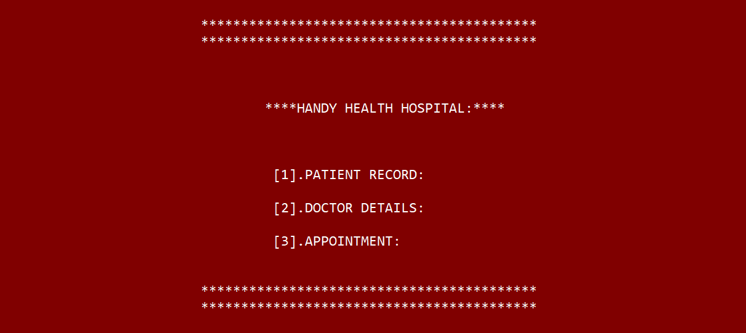**PRESS 3 for booking an appointment**
2. **Press 4 For Adding New Appoitment**

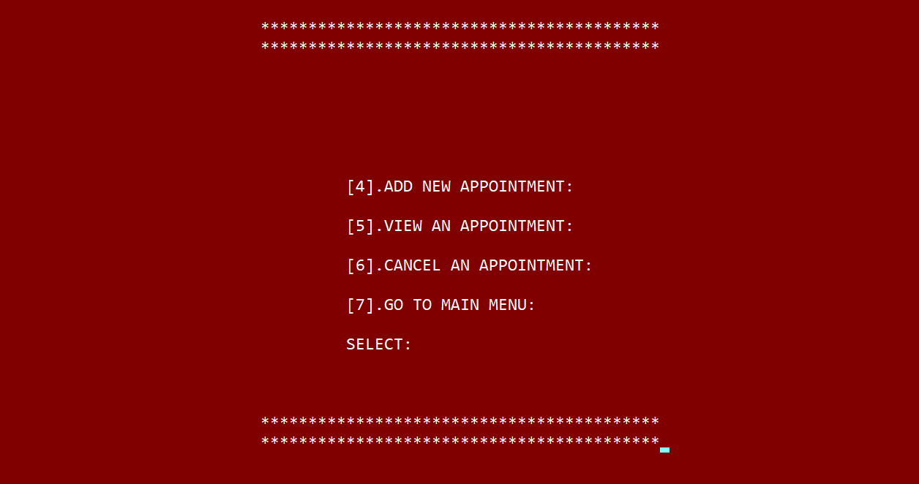

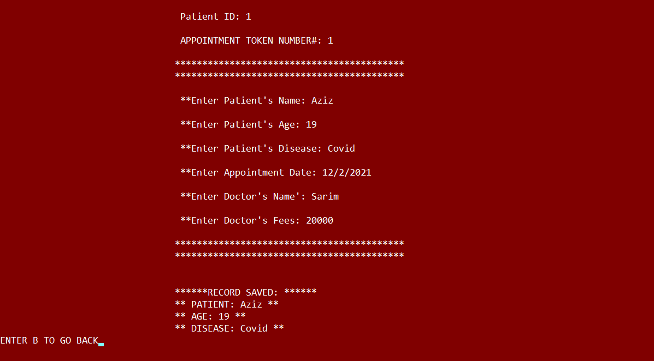

**Enter Patients Details and press B**

**Click on View An Appointment To See Records**

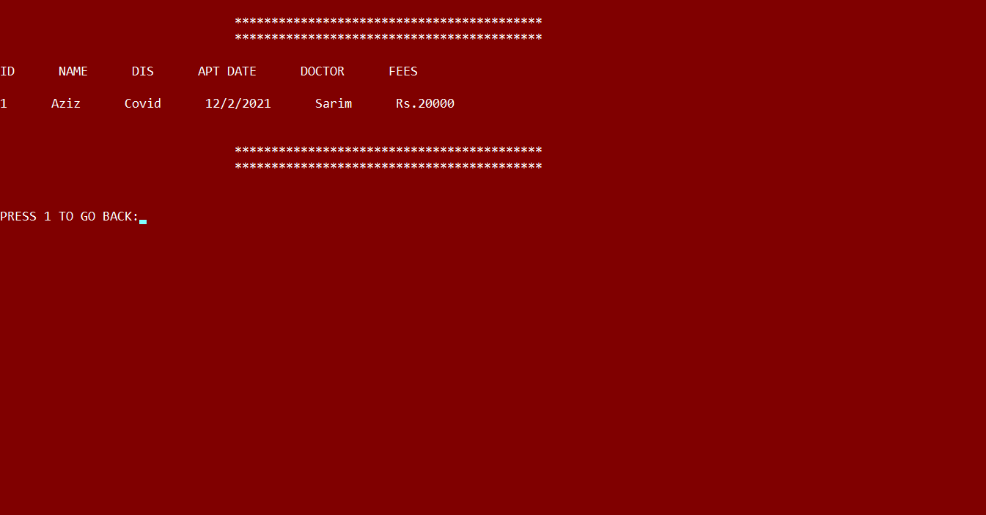

**HOW TO CANCEL ALL APPOINTMENTS:**

1. **Press 6**

**HOW TO VIEW DOCTOR DETAILS**

1. **Press 2**



**2. PRESS 13/14 FOR DOCTOR’S DETAILS**



**HOW TO SEE APPOINTED PATIENTS:**

1. **Press 1**



1. **Press 9**

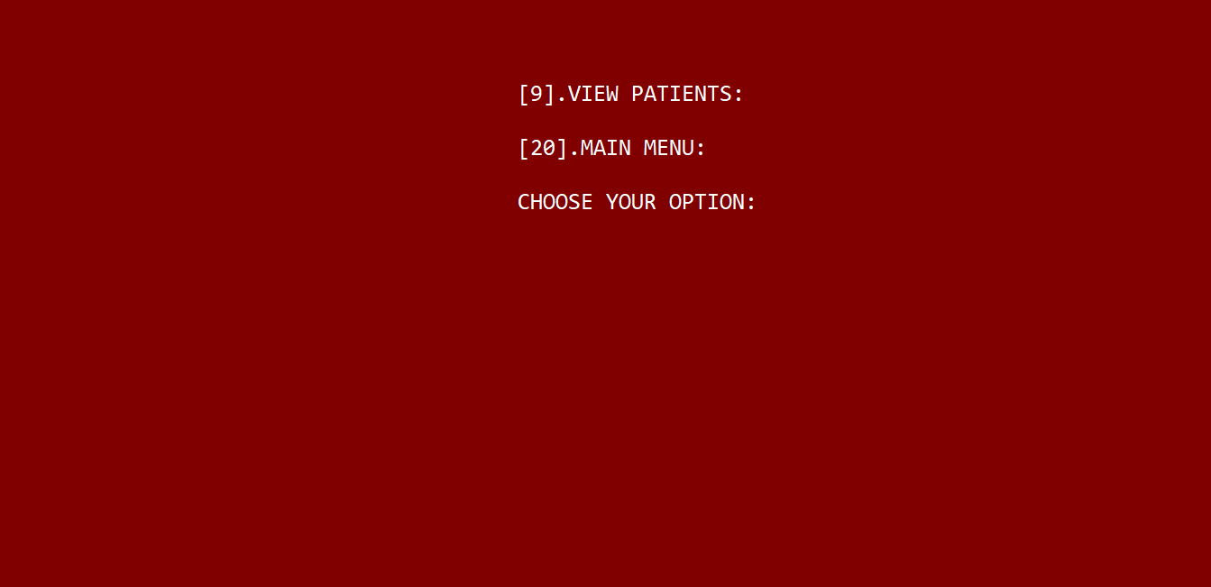

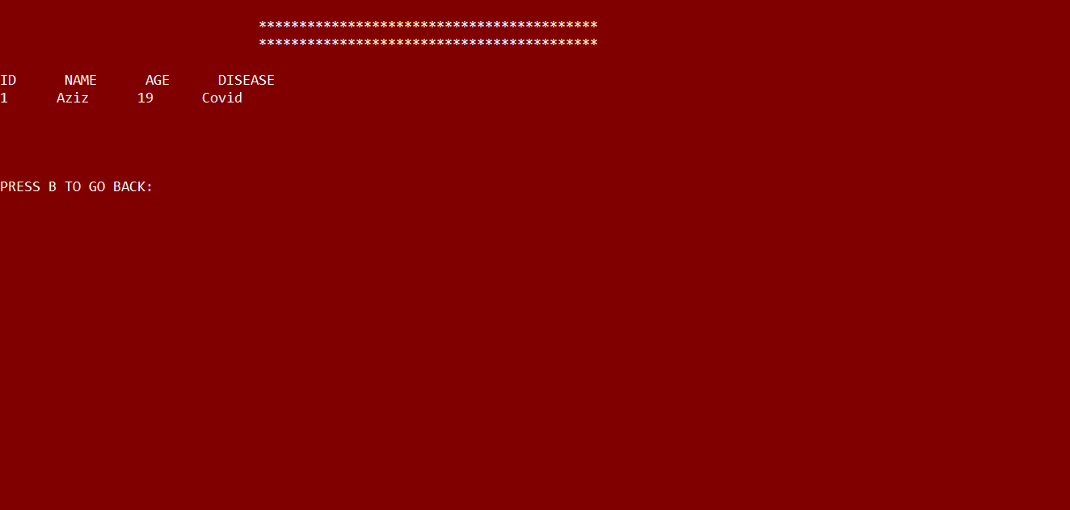

**5-FLOWCHART**

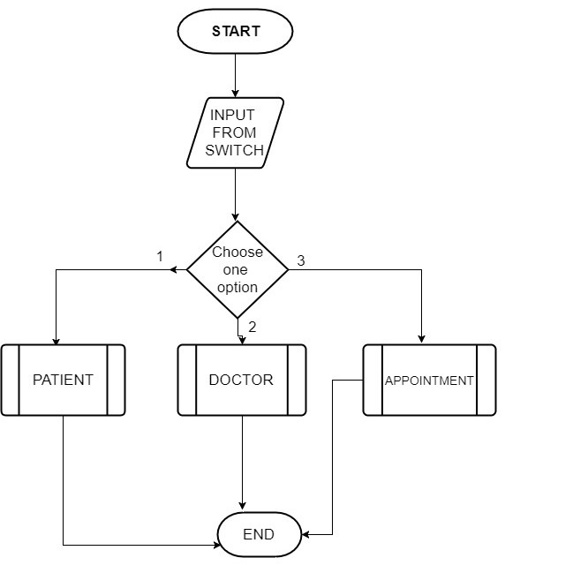

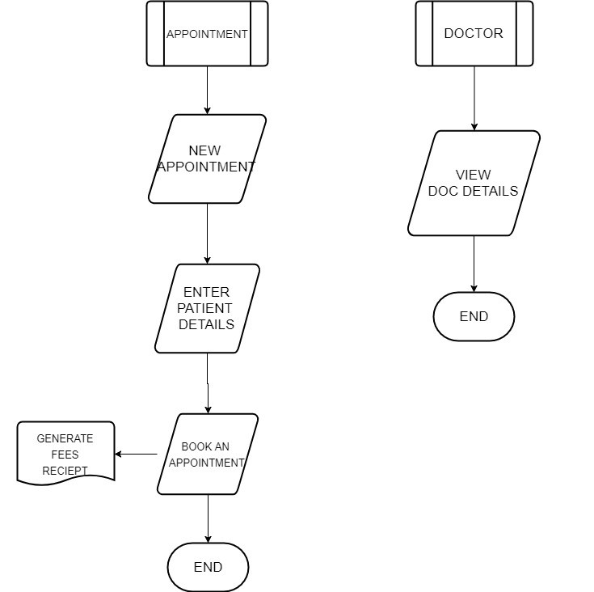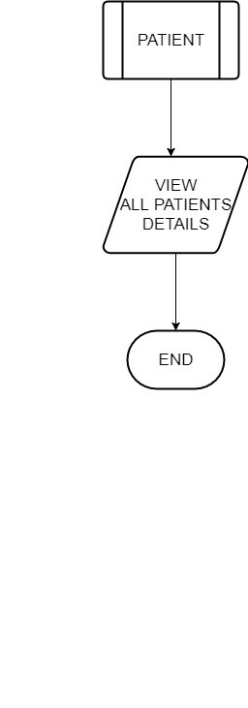

**Conclusion:**

We felt that the development of a Patient appointment

management system was necessary because of the antiquated

way in which many hospitals and clinic register and schedule patient’s appointments and records. In order to keep up with growing technology, we must seek ways to make certain processes less time consuming, more error free and more user friendly.